Test Scenarios for IRCTC Login Page

## Login page Access

Scenario: Verify that the IRCTC login page loads correctly when accessed.

Expected Outcome: The login page should load with all necessary elements visible and functional.

Actual Outcome:

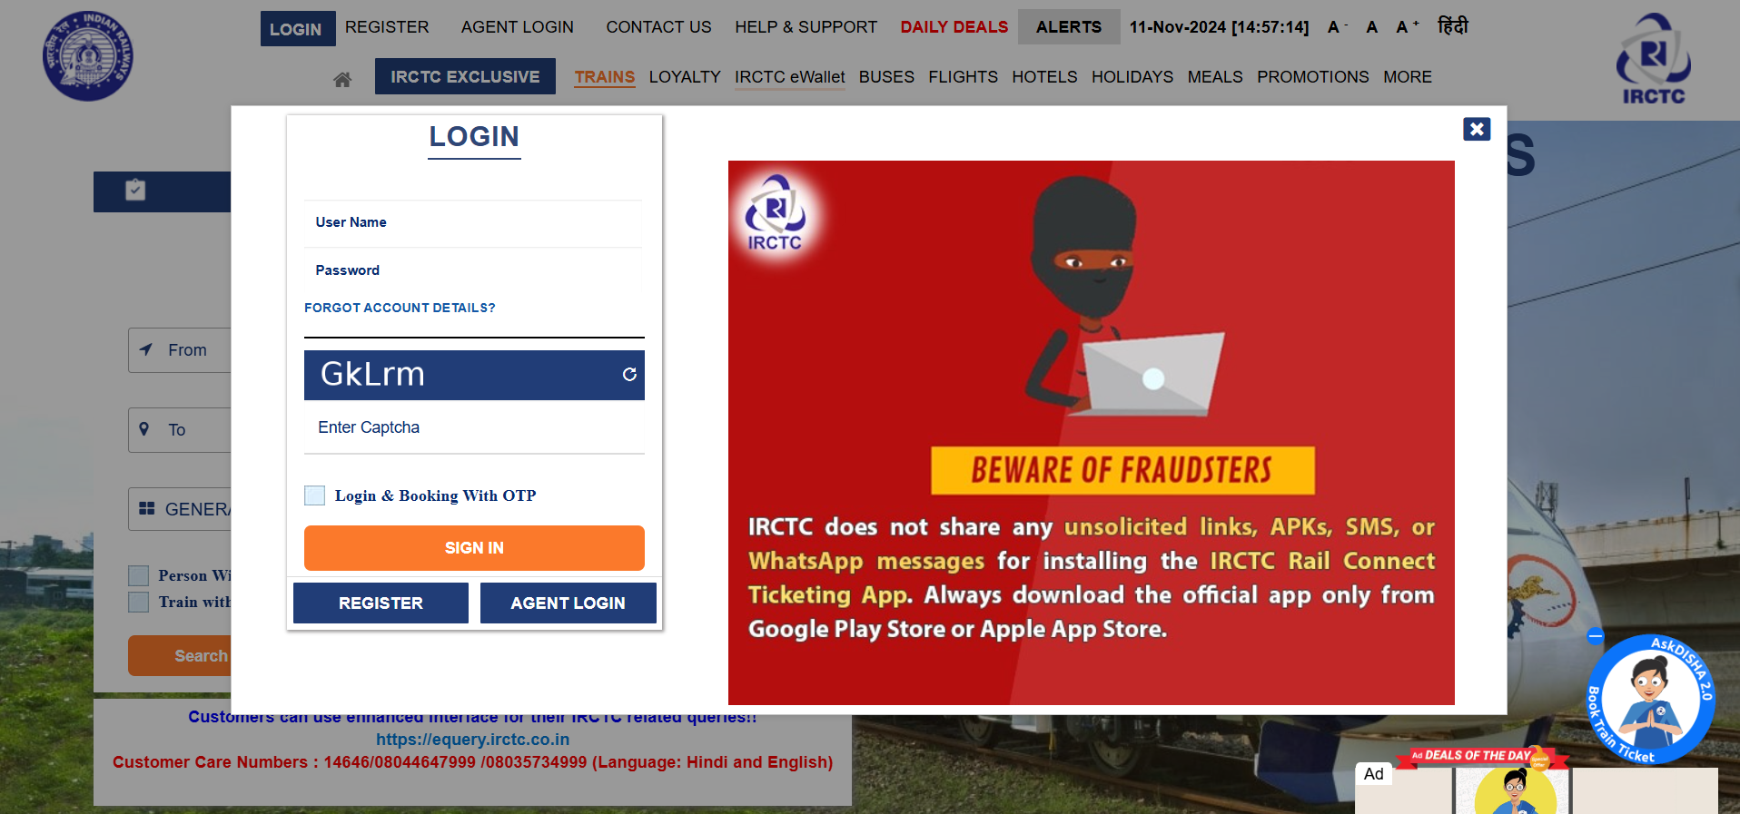

## Login Functionality

Scenario: Verify login functionality with valid and invalid credentials.

Expected Outcome: Users with valid credentials should be logged in, while those with invalid credentials should see an appropriate error message.

Actual Outcome:

Valid Credentials

Invalid Credentials

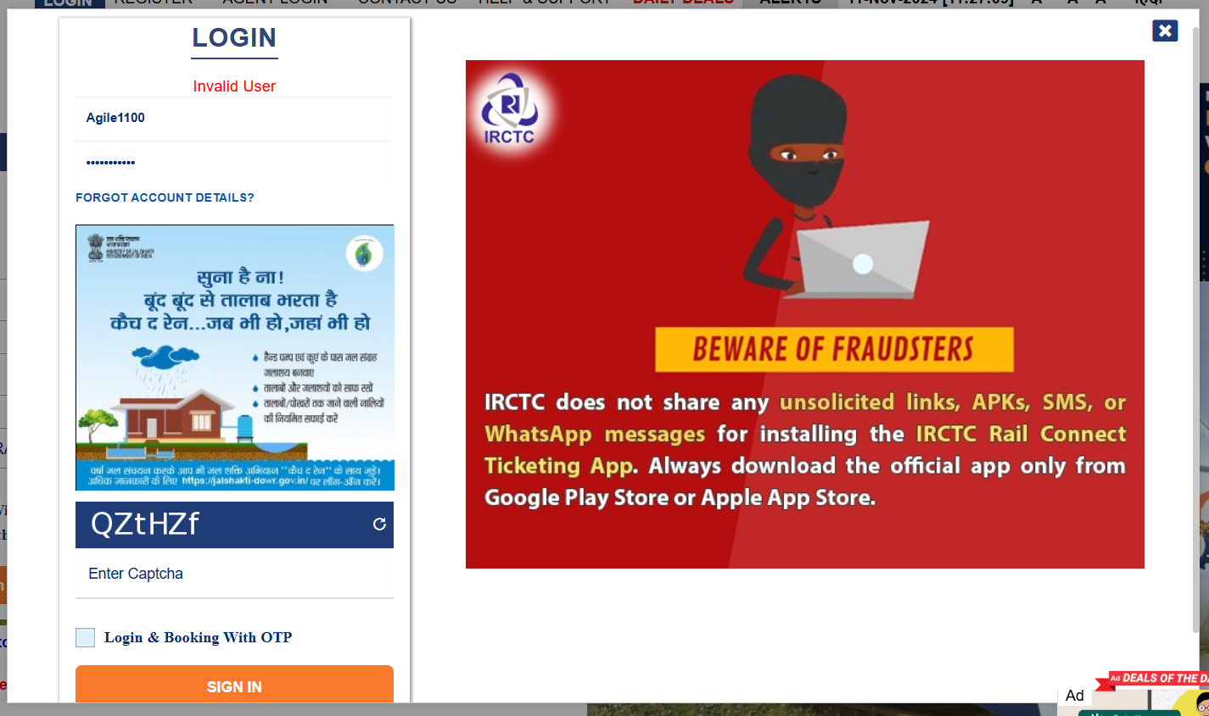

## Captcha Verification

Scenario: Verify Captcha Functionality on the Login Page

Expected Outcomes: Captcha is visible and clear; correct entry allows login; incorrect entry shows an error; refresh generates a new captcha; expired captcha prompts re-entry.

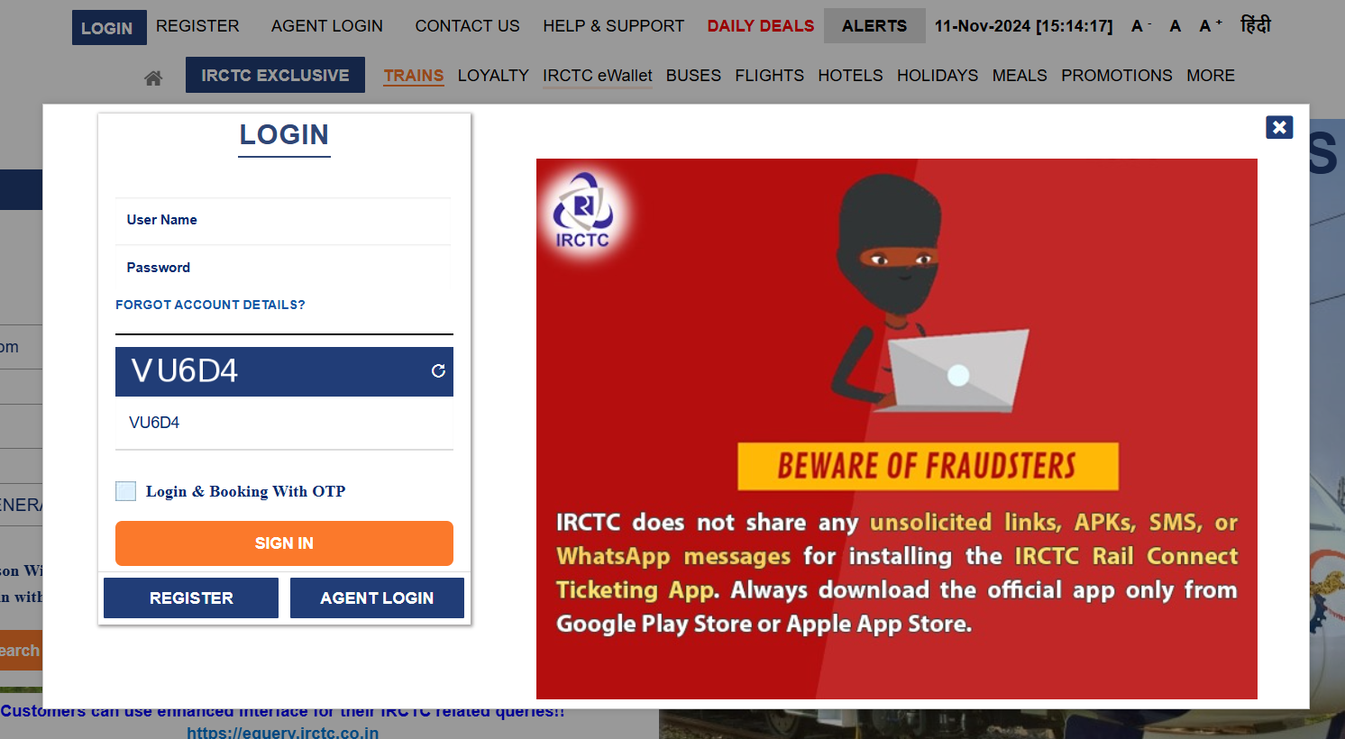

**Forgot Account Details**

Scenario: Verify that users can access the "Forgot Account Details" feature from the login page.

Expected Outcome: A "Forgot Account Details" link should be available, leading to the recovery process.

Actual Outcome:

## Login & Booking with OTP

Scenario: Verify that users can select the "Login with OTP" option on the login page.

Expected Outcome: The "Login with OTP" option should be visible and selectable on the login screen.

Actual Outcome:

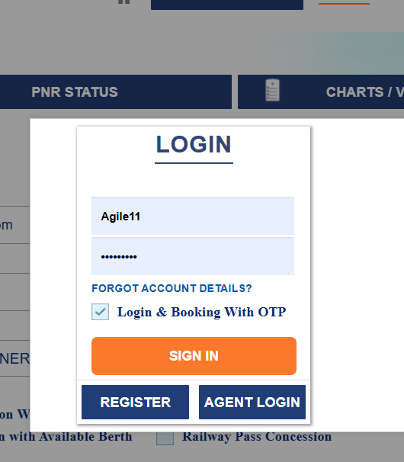

## Register Button

Scenario: Verify that users can click the register button.

Expected Outcome: A "Register" link should be available, directing users to the registration form.

Actual Outcome:

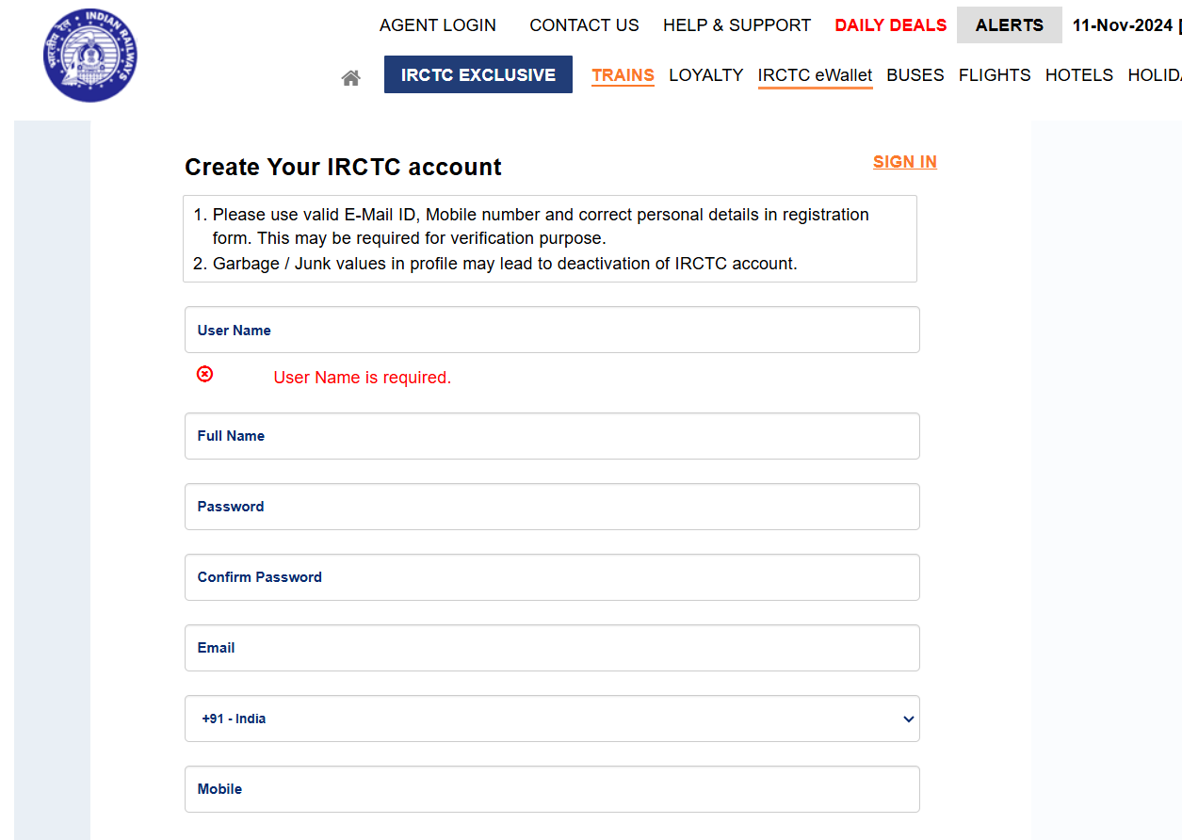

## Responsiveness

Scenario: Test the webpage’s responsiveness on various devices (desktop, mobile, tablet).

Expected Outcome: The page should display correctly and remain functional on all devices.

Actual Outcome:

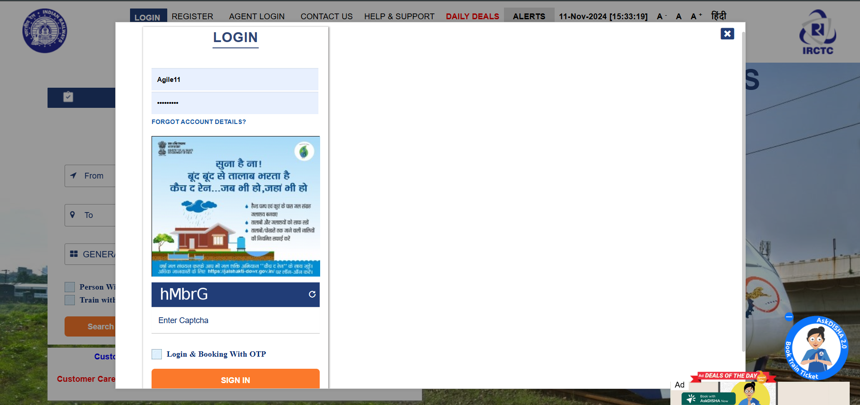

## User Interface Elements

Scenario: Verify that UI elements (buttons, dropdowns, fields) are labeled correctly and functional.

Expected Outcome: All elements should be easily accessible and labeled for clarity.

